PharmAcademic Release Notes: June 2025
The June 2025 PharmAcademic Release includes the following enhancements. For additional information, please visit the PharmAcademic Help Center or email support@mccreadiegroup.com.
New Functionality to Support APR Review Process
Help Center Articles: Managing Preceptor APRs, Completing the Electronic APR Form, Adding and Updating Preceptors and Staff, Assigning Roles in PharmAcademic
New APR Reviewer Role
The newly introduced APR Reviewer role enables programs to provide users with access to review and manage preceptor APRs, as opposed to utilizing the Designee role, which provides global access to the program. Users may be assigned only the APR Reviewer role, or they may have it in addition to other PharmAcademic roles. To update roles, go to Manage Program > Preceptors and Staff tab, and click "Edit" next to the person's name.
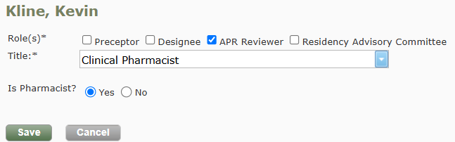

Access to Manage APRs
The path to the APR management page has been moved for easier access. Previously located on the Tools tab, now the access link is located on the Preceptors and Staff tab. The link “Request APR Submission and View Submitted Forms” is only available to users with the role RPD, Designee, or APR Reviewer.
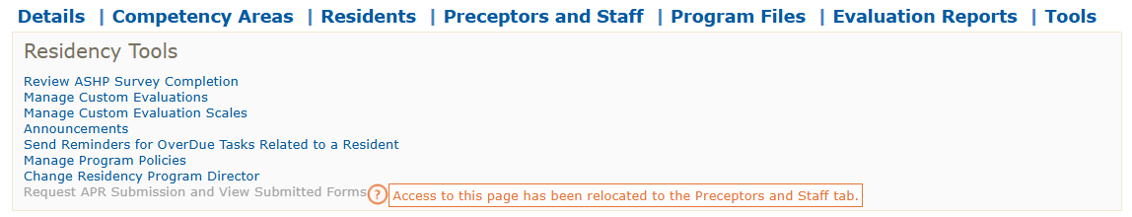
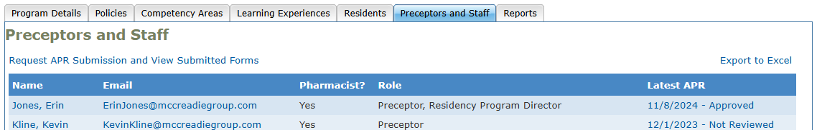

New APR Review Status
The APR management page has been updated to include a Review Status column, designed to aid programs in tracking and reviewing preceptor APRs.
When an APR is submitted, the APR Review Status will be “Not Reviewed.” RPDs, Designees, and users with the APR Reviewer role, can view the APR and click the review status to update the status and add internal notes. Status options include: “Not Reviewed”, “Review in Progress,” “Approved,” and “Approved with Development Plan.” The current Review Status is displayed on this page, on the Preceptors Tab for their reference, on the Preceptor Dashboard, and in reports. The internal notes, only available to the review team, are displayed on this page and in reports.
In conjunction, a new report “Current APR Status and Review Notes” was added allowing programs to download the review details for the latest APR submission for all preceptors. The report can be downloaded in the following locations:
- APR management page (by RPD/Designees and APR Reviewer)
- Preceptor Dashboard (by RPD/Designee and ASHP Surveyors)
- Program Reports tab (by RPD/Designee)
The report includes information about the review status and internal notes for the most recent APR submission for each preceptor. Note: If you would like to view past APR submissions, click View History on the grid.
Previous functionality still exists on this page, including the ability to view APR forms and send email requests to preceptors to submit their APRs.
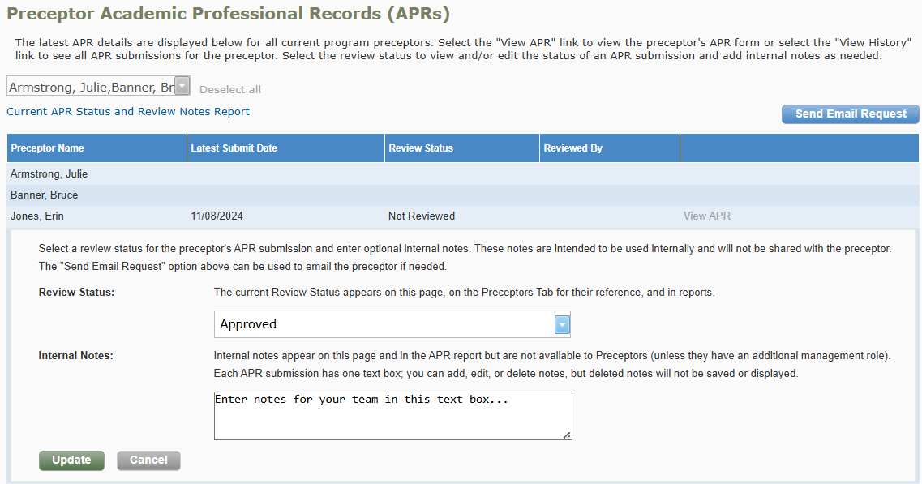
Visibility & Screen Changes
Changes to the Preceptors and Staff tab:
- New “Request APR Submission and View Submitted Forms” link was added to access the APR management page – only available to RPD/Designee and APR Reviewer.
- Latest APR column now also includes the APR Review Status. The links are active and the status is viewable to the RPD/Designee, APR Reviewer, and preceptors for their own APR.
- The Export to Excel report has been updated with the Current APR Review Status. This report is available to RPD/Designee, APR Reviewer, and ASHP Surveyors.
Changes to the Preceptor Dashboard:
- The Current APR Review status has been added to the APR submission date on the preceptor dashboard. As before, RPDs/Designees and ASHP Surveyors can click this link to view the submitted APR form.
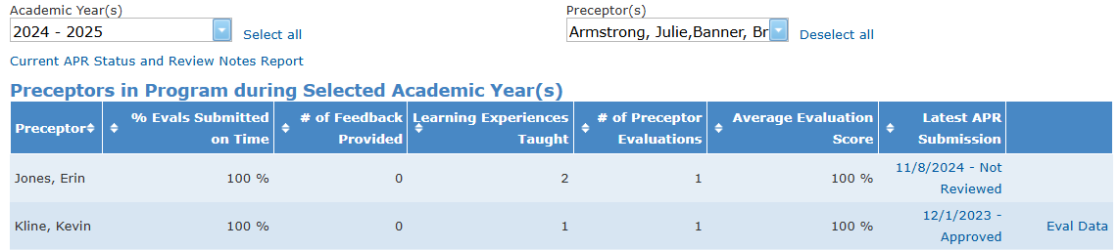
- The “Current APR Status and Review Notes” report was added to this page and can be downloaded by RPDs/Designees and ASHP Surveyors.
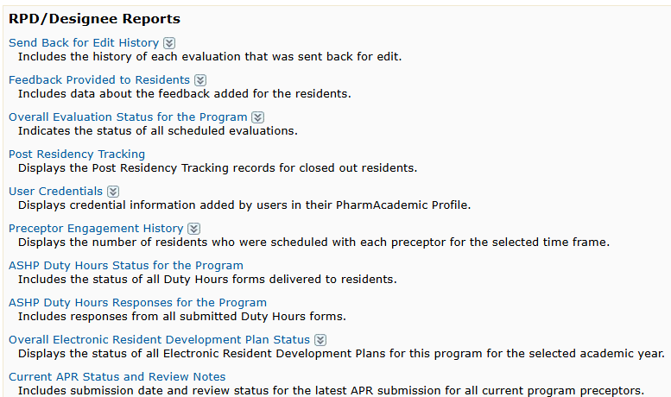
Change to the Programs Report page:
The “Current APR Status and Review Notes” report was added. It includes the submission date and review status for the latest APR submission for all current program preceptors. Only the RPD and Designee can access the report on this tab.

Updates to the APR: Optional Professional Engagement
Help Center Articles: Completing the Electronic APR Form
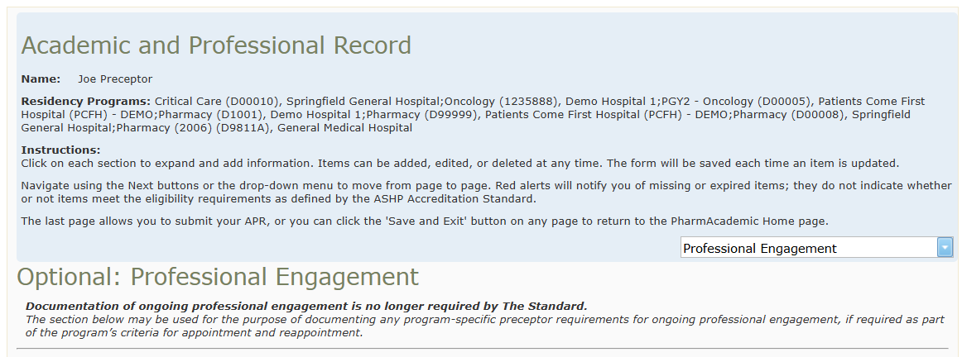
Page four of the Electronic APR, Professional Engagement, is now optional as ongoing documentation is no longer required by The Standard. Text has been added to the top of the page to inform preceptors of this change. Although optional, this section remains available for documenting program-specific requirements for ongoing professional engagement. Incomplete questions and expired examples will no longer flag users.

Updated Annual Report Analytics
Help Center Articles: Reviewing Annual Report Analytics
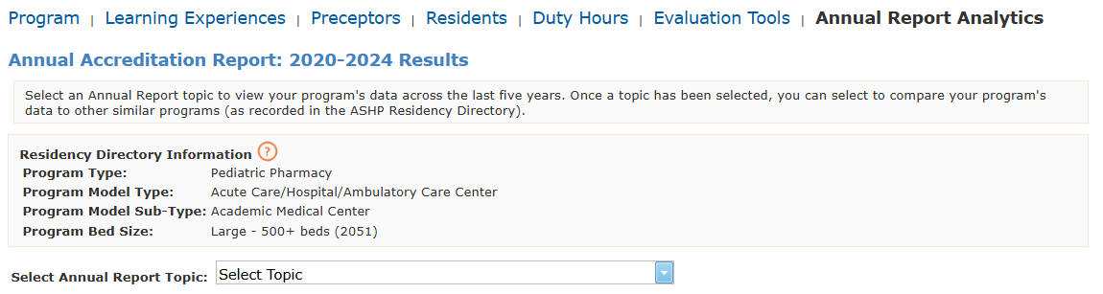
The 2024 ASHP Annual Accreditation Report data and updated ASHP Directory information have been incorporated into the Annual Report Analytics dashboards in PharmAcademic. RPDs and Designees can review survey responses to key questions from the past five years, including last year, and compare those responses with aggregate data from similar programs. To access, go to Dashboards > Annual Report Analytics.

